**Garage Management System**

**Project Overview**

This project is focused on the **Garage Management System**, designed to address the challenges of managing customer information, service scheduling, inventory tracking, and billing in automotive repair facilities. The goal is to deliver a comprehensive solution by leveraging the Salesforce platform and its advanced tools for customization and automation. Through this project, we aim to enhance operational efficiency, improve user experience for both staff and customers, ensure data accuracy, and support the long-term goals of streamlining garage operations and increasing customer satisfaction.

**Objectives**

The primary objective of the project was to develop a centralized platform to automate and optimize garage operations. Specifically, the project aimed to:

* Simplify customer management by storing and retrieving customer and vehicle data efficiently.
* Implement an optimized scheduling system for service appointments.
* Automate inventory tracking and billing processes.
* Provide insightful dashboards and reports for performance analysis and decision-making.

These objectives align with the broader goal of modernizing garage operations, reducing operational costs, and delivering exceptional customer service. The system ensures that garage staff can focus more on providing quality services rather than managing administrative tasks. The real-time dashboards and reports also empower managers with actionable insights, enabling better planning and resource utilization.

**Salesforce Key Features and Concepts Utilized**

The Garage Management System utilized a variety of Salesforce tools and features to deliver a robust and efficient solution. The project made extensive use of Salesforce’s customization capabilities, allowing the creation of objects, fields, and workflows tailored to the unique requirements of garage operations.

It includes:

* **Custom Objects and Relationships**: Custom objects for Customers, Appointments, Services, and Billing Details were designed to manage data logically and ensure seamless relationships between processes.
* **Lightning App Builder**: A responsive and visually appealing interface was built using Salesforce Lightning, allowing garage staff to navigate between tasks effortlessly.
* **Apex Classes and Triggers**: Complex logic, such as service amount calculations and workflow automation, was implemented to reduce manual intervention and improve accuracy.
* **Validation Rules**: These were used to enforce data accuracy by implementing constraints such as correct vehicle number formats and limiting service ratings to a scale of 1–5.
* **Reports and Dashboards**: Custom dashboards and reports provided real-time insights into operational performance, allowing better management of resources and identifying areas for improvement.
* **Flows**: Automated workflows were created for processes like sending payment confirmation emails and updating service statuses post-quality checks.

These Salesforce features worked together to create an interconnected system that streamlined all aspects of garage management.

**Detailed Steps to Solution Design**

The design and implementation of the **Garage Management System** followed a structured approach to ensure the solution met all the business requirements of the garage, optimized daily operations, and provided the necessary automation for efficiency. Below are the key steps taken during the design phase:

**1. Creating the Salesforce Developer Account**

The first step in the process was to create a Salesforce developer account, which provided access to Salesforce’s suite of tools. The developer account was crucial for setting up a sandbox environment where the system could be developed and tested without affecting live data.

**Steps:**

* Go to the Salesforce Developer Signup page.
* Fill out the required details such as name, email address, company name, and a unique username.
* After signing up, verify the email account and complete the login process.

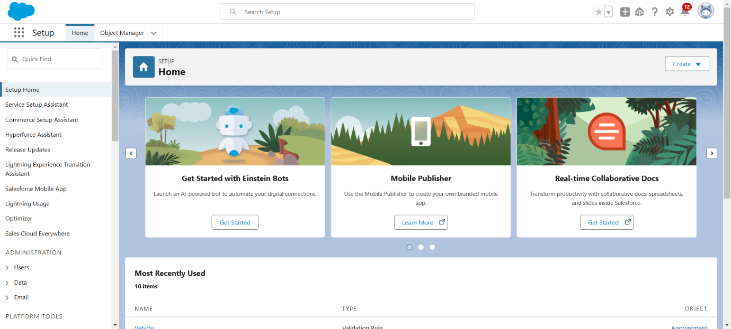

**2. Defining Data Models and Creating Custom Objects**

The next step involved defining the data models that would represent the key business elements within the garage. The Garage Management System required the creation of several custom objects to store and manage specific information about customers, appointments, services, and billing.

**Key Custom Objects Created:**

* **Customer Details:** This object stores information about customers, including their contact details and vehicle information.
* **Appointments:** Used to manage the appointments scheduled for service, including appointment date, customer, and vehicle.
* **Service Records:** Stores information about the specific services performed on vehicles, including service types, parts used, and the service completion status.
* **Billing Details:** Manages the invoicing process, including service charges, parts costs, payment status, and customer feedback.

**Relationships between Objects:**

* + - Relationships between these objects were established using Salesforce’s "Lookup" and "Master-Detail" relationship types. This ensured that related records were linked appropriately, such as linking a customer to an appointment or a service record to a billing entry.

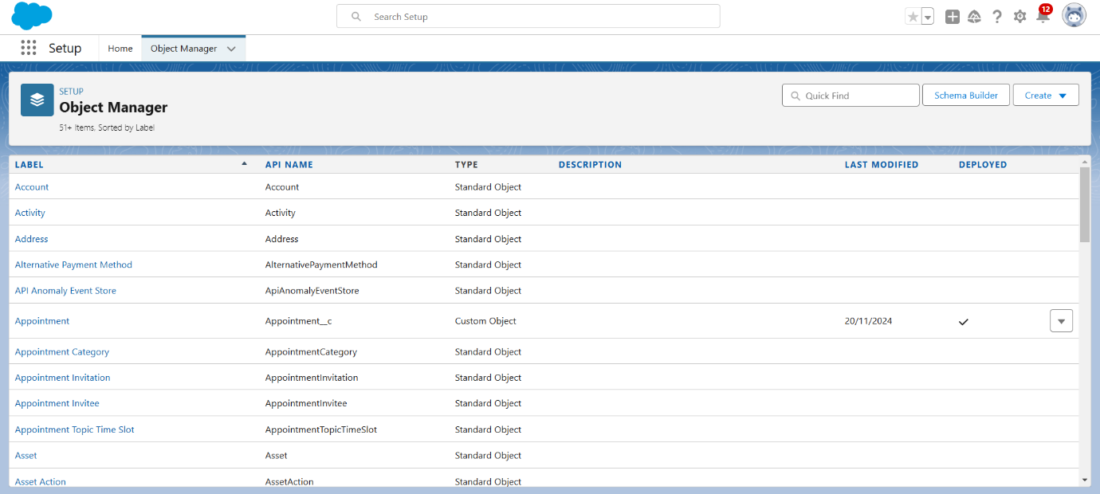

**3. Developing the User Interface with Lightning App Builder**

Once the objects were created, the focus shifted to creating an intuitive user interface (UI) to allow users to interact with the system. The **Salesforce Lightning App Builder** was used to create a custom app that included all necessary components and tabs for managing the garage operations.

**Steps for Building the UI:**

* **App Creation:** A new app was created using the Lightning App Builder, named **Garage Management System**. The app was designed to serve as the main navigation hub for users.
* **Tabs Creation:** Custom tabs were created for each object (e.g., Customer Details, Appointments, Service Records, Billing). These tabs allowed easy navigation between different records.
* **Page Layouts:** Page layouts were configured for each object to ensure that relevant fields were displayed in a logical and user-friendly manner.
* **Record Types and Page Layout Assignments:** Different record types were used for objects like appointments (e.g., regular service, emergency repair), and custom page layouts were assigned accordingly to provide users with specific data based on the type of record.

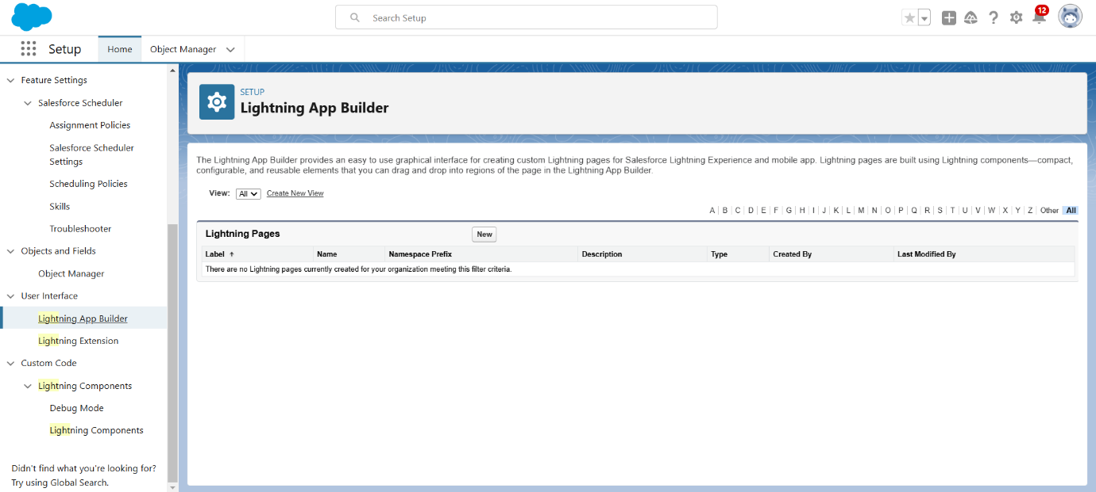

**4. Implementing Validation Rules and Data Integrity Measures**

In order to ensure the quality of data and avoid errors in critical business operations, **validation rules** were implemented on various fields. These rules helped to enforce the data entry standards and maintain consistency.

**Examples of Validation Rules:**

* + - 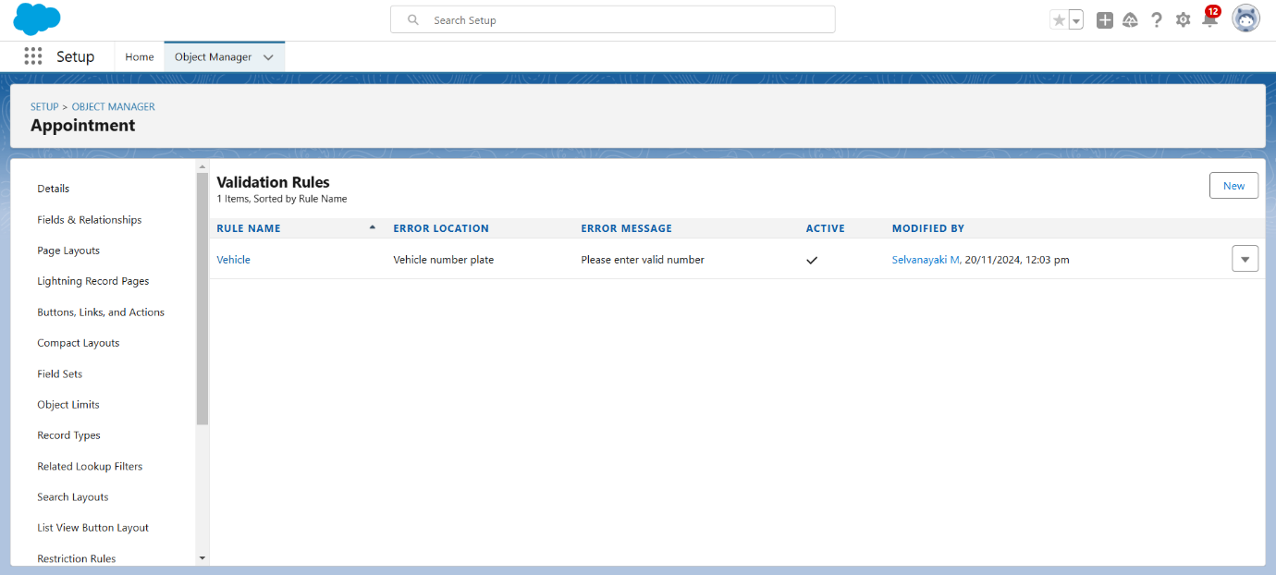**Vehicle Number Plate Validation:** A rule was set up to enforce the proper format for vehicle number plates, ensuring they met the required pattern.
    - **Rating for Service Validation:** A rule was applied to ensure that service ratings were between 1 and 5, avoiding invalid ratings.
    - **Appointment Date Validation:** Validation was implemented to ensure that appointment dates could not be set earlier than the current date.

**5. Automating Workflows with Apex Classes and Triggers**

A major aspect of the system’s design was the automation of business logic to reduce manual intervention and improve operational efficiency. Salesforce’s **Apex classes and triggers** were utilized to create automation rules and perform complex calculations.

* **Apex Class for Service Amount Calculation:** An **Apex class** was developed to calculate the service amount based on the services selected by the customer (e.g., maintenance, repair, or parts replacement). The class was triggered every time an appointment record was created or updated.
* **Apex Trigger for Automatic Service Status Updates:** Another **Apex trigger** was written to automatically update the service status of a service record once a quality check was completed. This ensured that records remained up-to-date without requiring manual intervention.

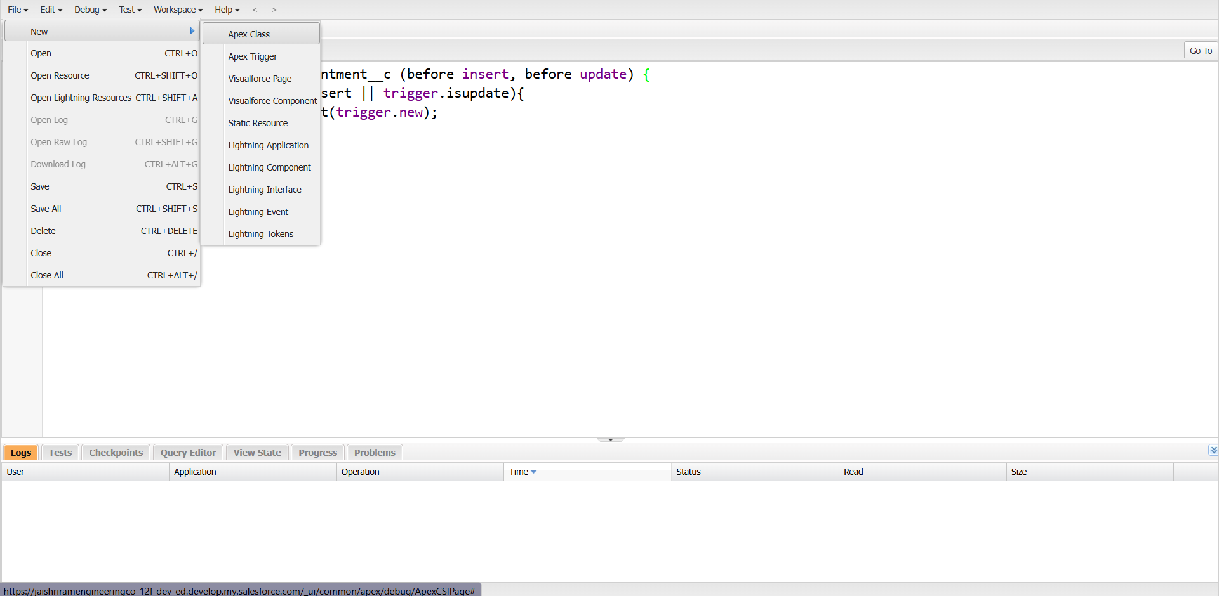

**6. Designing Reports and Dashboards**

The next step was to design and configure reports and dashboards that would provide real-time insights into the performance of the garage. Salesforce’s **Report Builder** and **Dashboard Builder** tools were used to create customized reports that presented data in a visually appealing and easy-to-understand format.

**Types of Reports Created:**

* + - **Service Efficiency Report:** A report showing the time taken to complete different types of services, helping the garage assess its operational efficiency.
    - **Revenue and Payment Tracking Report:** A report tracking the payments received for services and parts, showing the total revenue generated over a specific period.
    - **Customer Feedback Report:** A report aggregating customer feedback ratings to identify areas for service improvement.

**Dashboards:**

* + - **Service Status Dashboard:** A real-time dashboard displaying the status of ongoing services, allowing the garage manager to track job progress.
    - **Revenue Dashboard:** A dashboard summarizing the total revenue, payments made, and the status of billing, providing insights into the financial health of the garage.

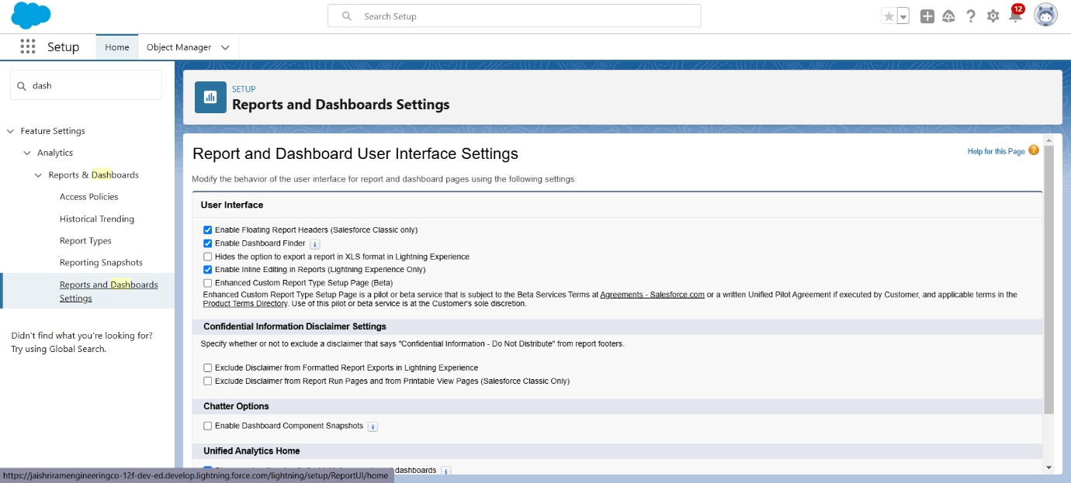

**7. Implementing Automation with Flows**

Salesforce **Flows** were used to automate complex business processes that would otherwise require manual intervention. The flows were created using the **Flow Builder**, which allowed for a visual, no-code approach to automation.

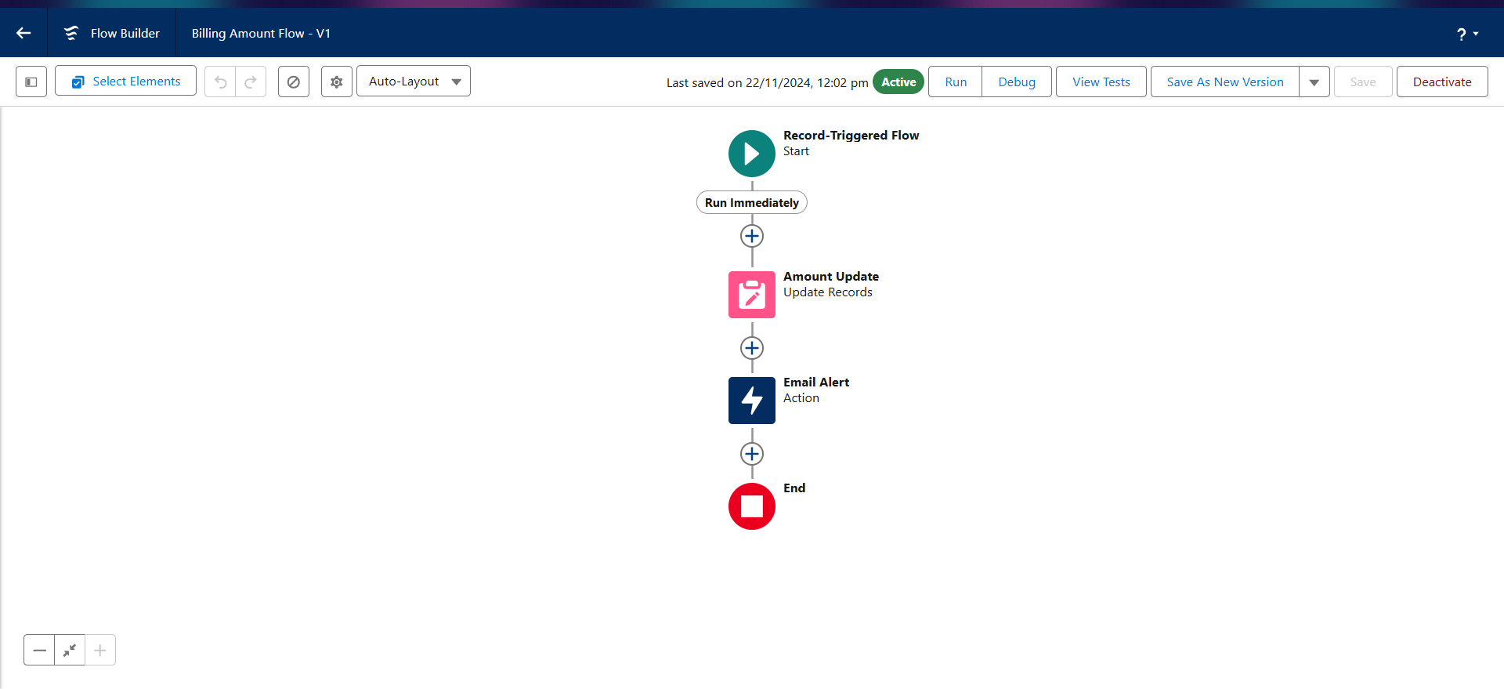**Examples of Automated Flows:**

* + - **Appointment Confirmation Flow:** When an appointment is booked, a flow was set up to automatically send a confirmation email to the customer, including appointment details.
    - **Payment Update Flow:** After a payment is received, the flow automatically updates the payment status in the Billing Details object and triggers an email notification to the customer.

**8. Security Configuration: Profiles and Permissions**

Once the core functionality was set up, the system’s security and user access controls were configured. Profiles and permission sets were used to define what each user could view or modify within the system.

**Profiles Created:**

* + - **Garage Manager:** The Garage Manager profile had access to all objects and data, including reports, service records, and billing details.
    - **Mechanic:** The Mechanic profile had restricted access, only able to view and update service records and appointments.
    - **Admin:** The Admin profile had full access to all configurations, including object creation, field updates, and system settings.

**9. User Training and Adoption**

Once the system was fully designed and tested, it was essential to ensure that all users were trained on how to use the system effectively. Training materials were created, including user manuals and video tutorials, covering key tasks like adding customers, scheduling appointments, and generating reports.

**User Adoption Strategies:**

* + - **Walkthrough Sessions:** Live demonstrations were held to walk users through the system’s functionality.
    - **Help Guides and Tooltips:** Built-in help guides and tooltips within the system provided on-demand assistance to users.
    - **Feedback Collection:** A feedback mechanism was introduced to gather input from users on the system's usability and to identify areas for future improvements.

**Testing and Validation**

To ensure the system’s reliability and usability, a comprehensive testing strategy was implemented:

* **Unit Testing:** Apex classes and triggers were rigorously tested to validate their functionality and ensure they handled all scenarios correctly.
* **Validation** **Testing**: All validation rules were tested to confirm that data entry errors, such as invalid vehicle numbers or out-of-range service ratings, were flagged appropriately.
* **User Interface Testing**: Lightning components were tested across devices and browsers to ensure compatibility and usability.
* **End-to-End Testing**: The entire workflow was tested, from customer record creation to billing and report generation. This ensured that all integrated processes worked seamlessly.

This thorough testing approach ensured that the system met all project requirements and provided a smooth experience for users.

**Key Scenarios Addressed by Salesforce in the Implementation Project**

The Garage Management System efficiently tackled various challenges commonly faced by automotive repair facilities. Leveraging Salesforce’s advanced capabilities, the project addressed critical scenarios related to customer management, service scheduling, inventory tracking, billing, and analytics. By integrating automation and real-time data handling, the system streamlined operations, reduced manual intervention, and enhanced the overall user experience for both staff and customers.

**Scenarios addressed include:**

* **Customer Management:** The system provided a centralized repository for customer and vehicle information, enabling quick and easy retrieval of records. This ensured that service history, customer preferences, and vehicle details were readily accessible for better customer support.
* **Appointment Scheduling**: An optimized appointment booking system was implemented to reduce scheduling conflicts and efficiently allocate resources. This improved time management and reduced customer wait times.
* **Inventory Tracking**: Automation was integrated to track parts usage during services. The system ensured real-time updates to inventory levels, helping prevent shortages and overstocking issues.
* **Billing Automation**: The project introduced an automated billing process that generated invoices with detailed service and parts breakdowns. This not only ensured accuracy but also enhanced transparency with customers.
* **Analytics and Reporting**: Dashboards and reports were designed to provide actionable insights into garage performance. Metrics such as service efficiency, revenue trends, and customer satisfaction ratings were visually represented, helping management make informed decisions.

**Conclusion**

The **Garage Management System** successfully implemented a Salesforce-based solution that improved operational efficiency by automating processes and providing real-time insights. This not only enhanced customer satisfaction but also reduced manual efforts. The system's scalability ensures that garages can adapt to future business needs, making it a benchmark for transforming traditional business practices with technology.